* High-level architecture diagram of the system, identify all major components

Please see the diagram folder.

* Your technology selection and a brief explanation for your selection.

Technologies Used

1. Spring Boot
2. Spring Data
3. Hibernate
4. Spring Rest
5. Thymeleaf
6. MySql

I wanted to design this application by applying MVC pattern. So I decided to use Spring boot which simplifies spring development and reduces development time by avoiding a lot of configurations. As well as, It is very easy to integrate Spring Boot Application with Spring JDBC, Spring ORM, Spring Data, Spring Security etc.

According to the requirement, the proposed system should expose API to build 3rd party dashboards. So I have implemented this by giving Rest Api endpoints which can access from other users.And Spring Boot helps to implement many approaches to secure rest api endpoints when accessing from 3rd party users.

* Choose one of the workflows ….
  + Produce the sequence diagram for your selected flow.

Please see the diagram folder

* + Create the entire project structure

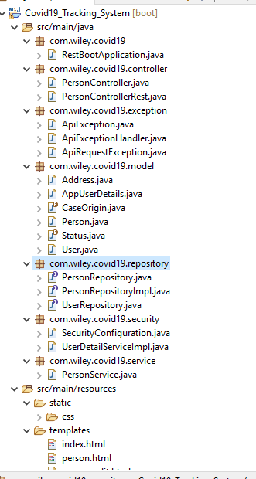

* + Implement API as well as UI for the selected flow, which should be testable and deployable.

Notes :-

Please note that UI validation is not implemented.

* Share the code by sharing your repository or any other way.

Git Repository